Traversal Binary Tree
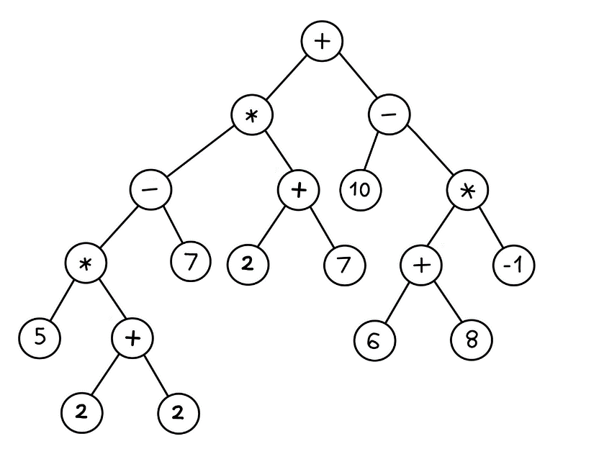
From expression tree above, create:
- Infix notation
- Prefix notation
- Postfix notation

- (5 * (2 + 2) – 7) * (2 + 7) + (10 – ((6 + 8) * -1))
- + * - * 5 + 2 2 7 + 2 7 – 10 * + 6 8 -1
- 5 2 2 + * 7 – 2 7 + * 10 6 8 + -1 * - +

